Mr. Moonlight

A little Bit of Style

Mustard 2026

Index

Visual Style____________________3
Death to the World_____________16
The enemy______________________17
3D Character style_____________18
Audio__________________________20

Visual Style
While Mr. Moonlight is set in Alaska in 1979, the style we want to approach is a mix of grunge, acid, and punk. Mixed with punk Christian elements. The game is a first-person shooter and is always in the first-person perspective.
The design of the characters and the design of the few UI elements, as well as the tone of the game and the characters themselves, Tracy being herself a punk; all of this will aim to have that style.

Grunge
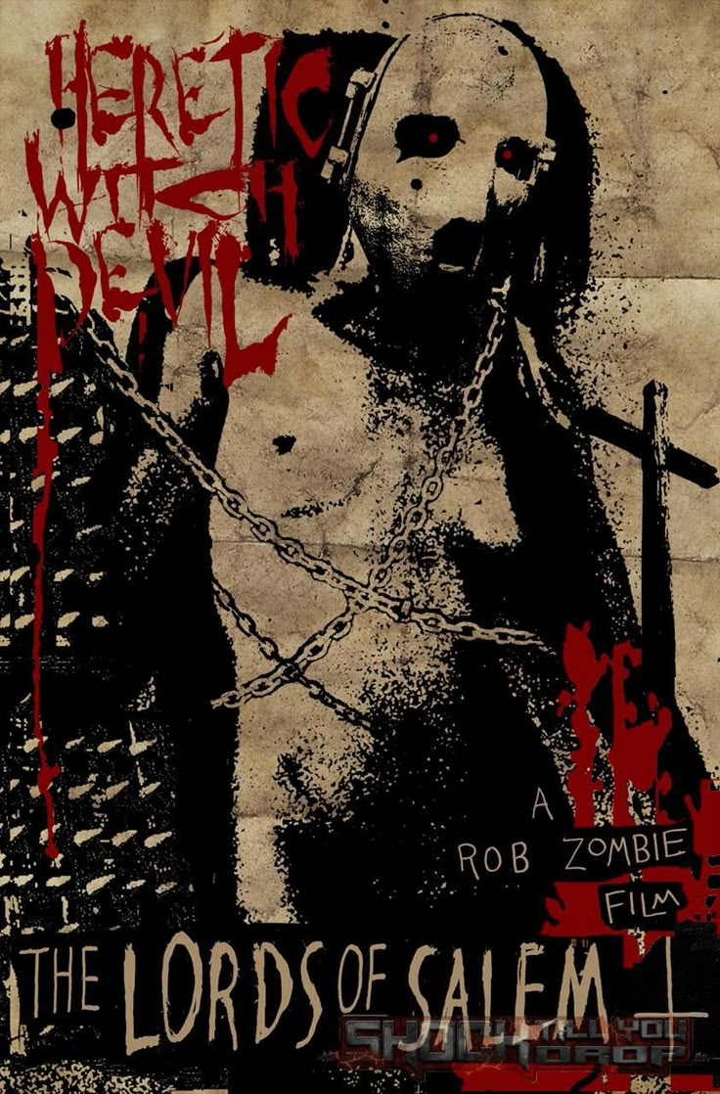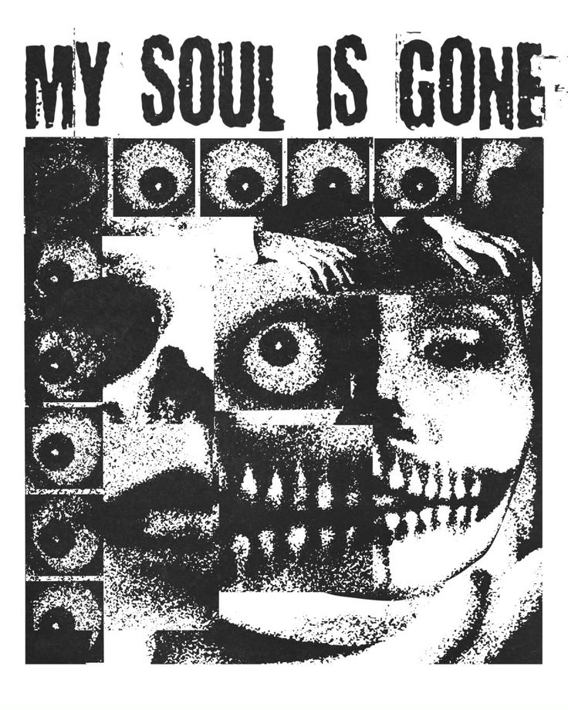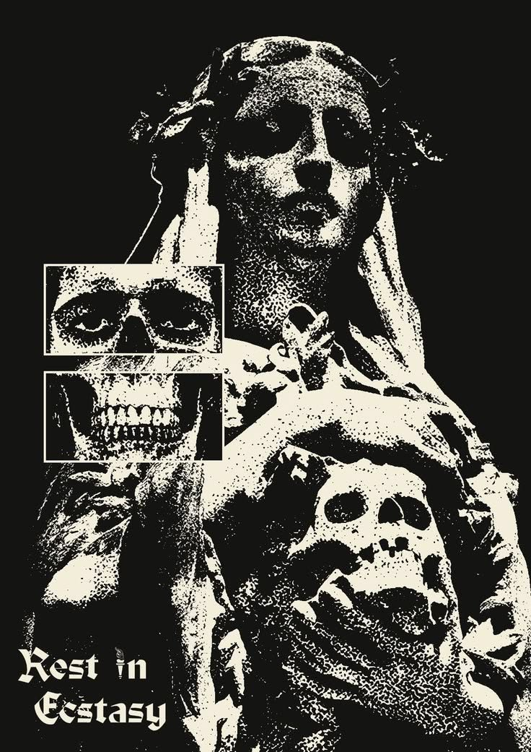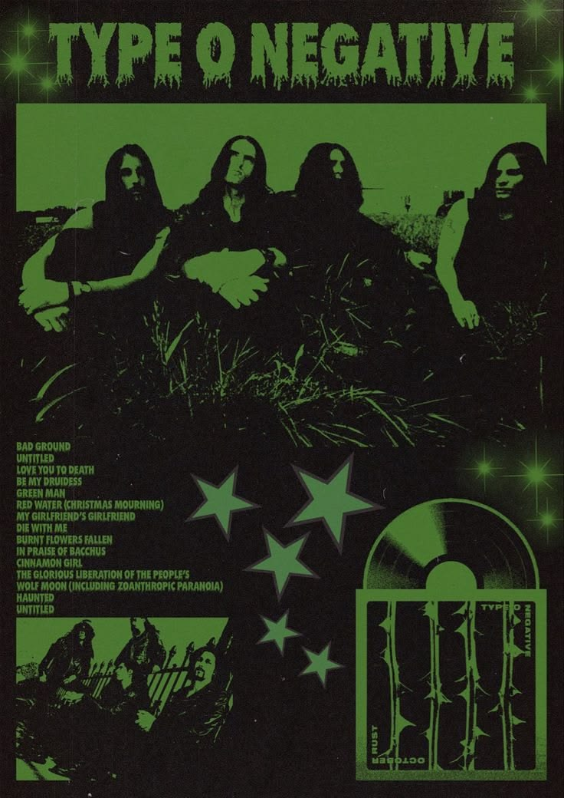

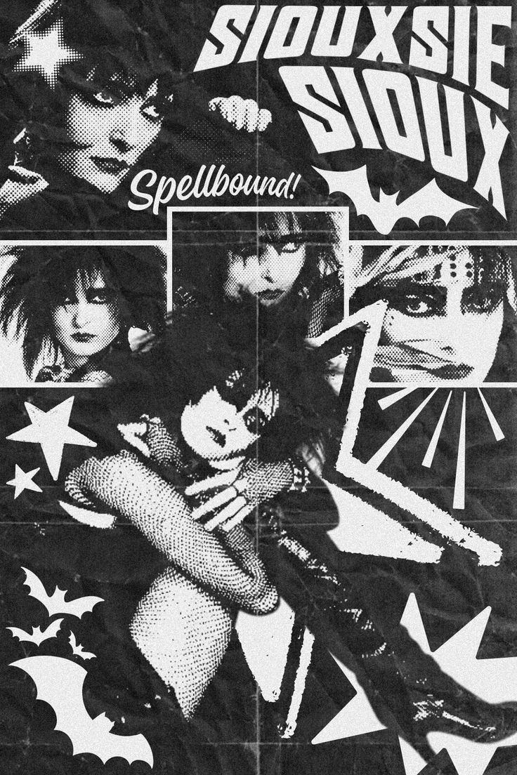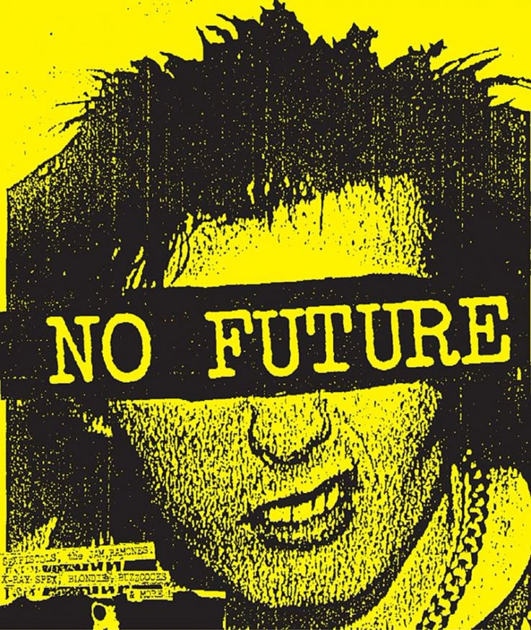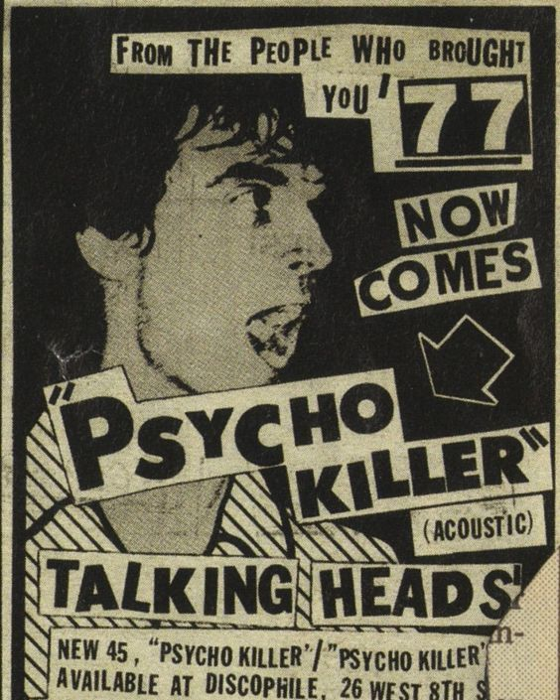

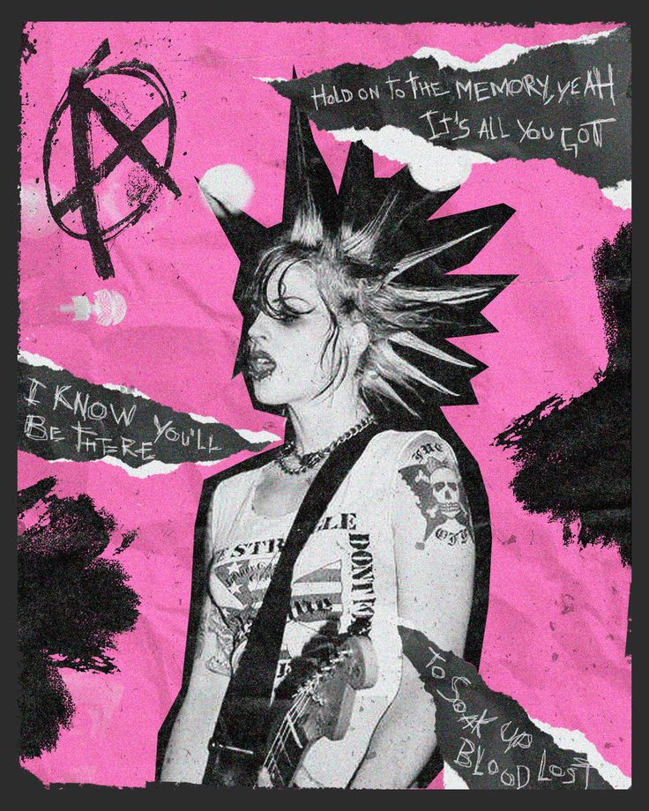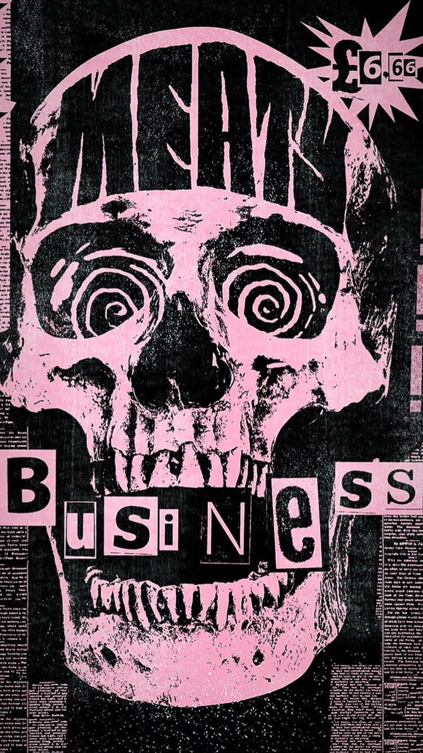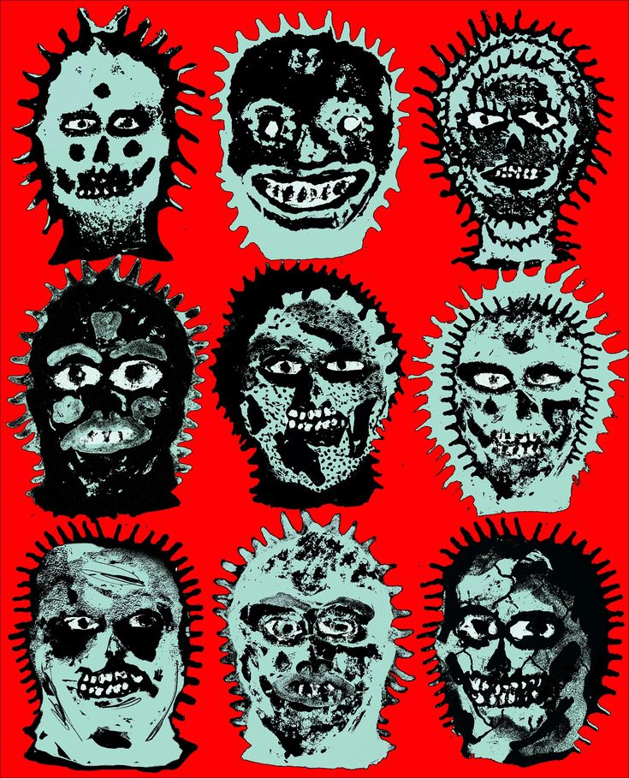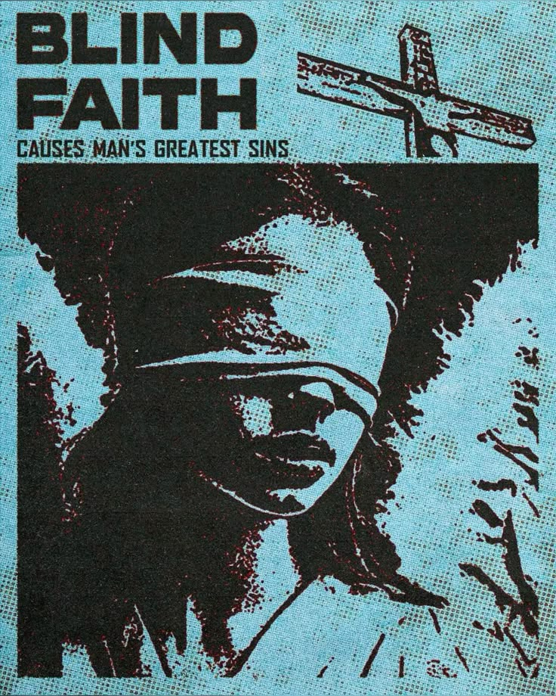

Acid

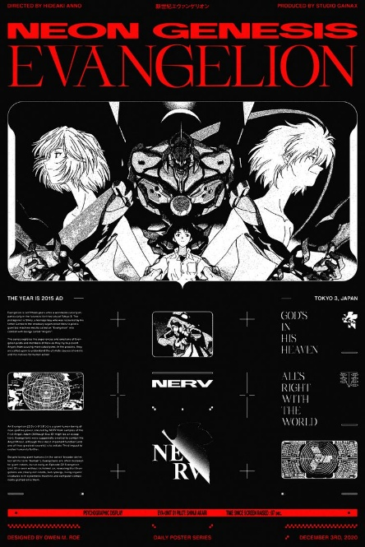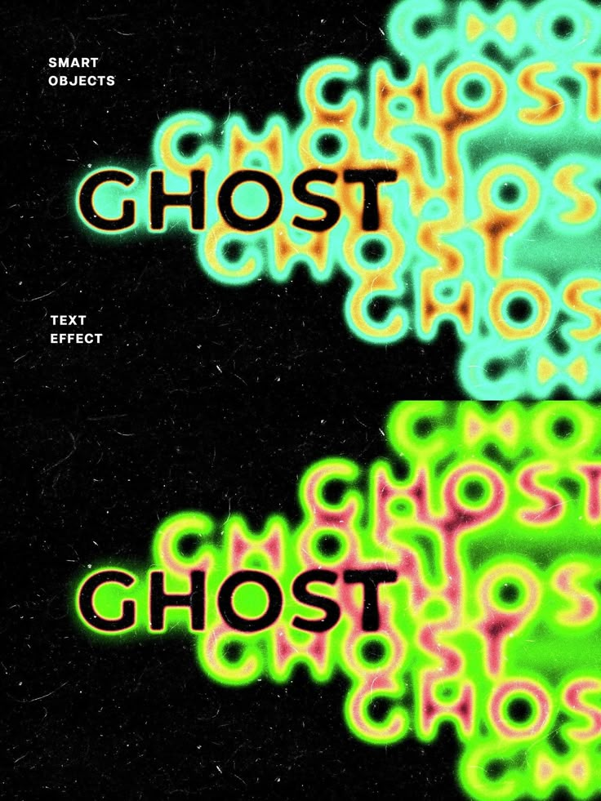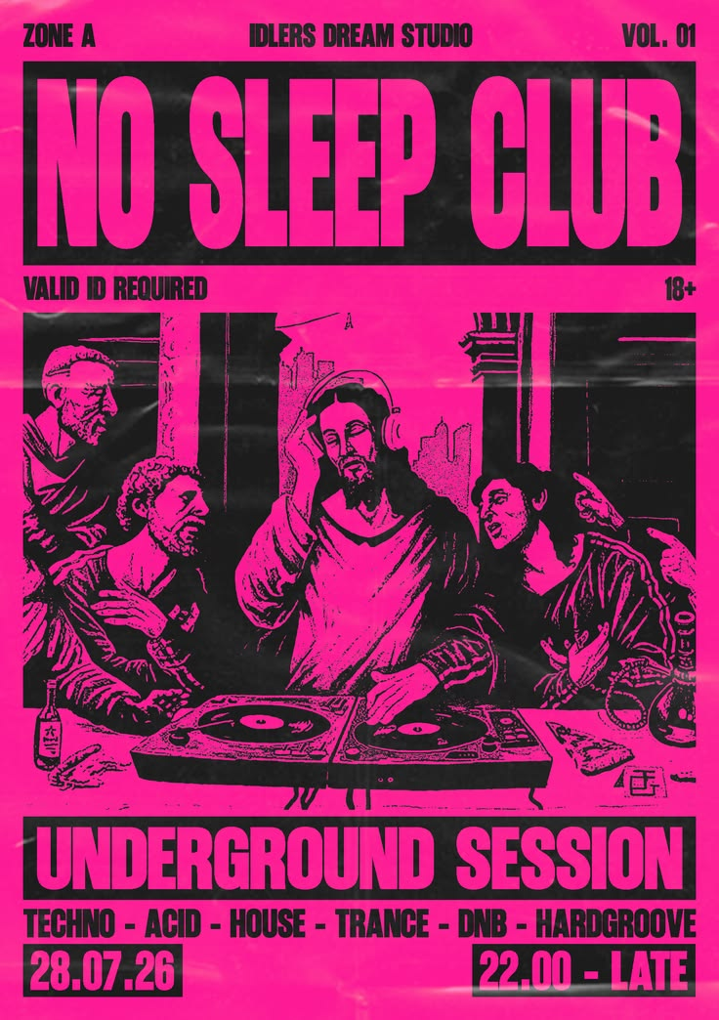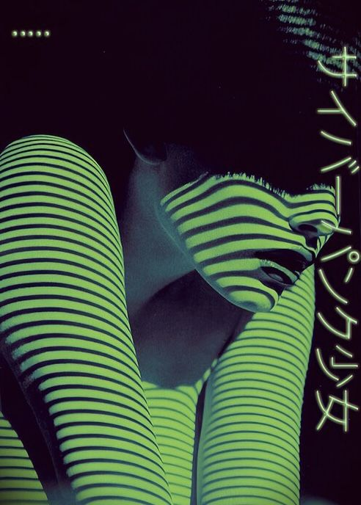

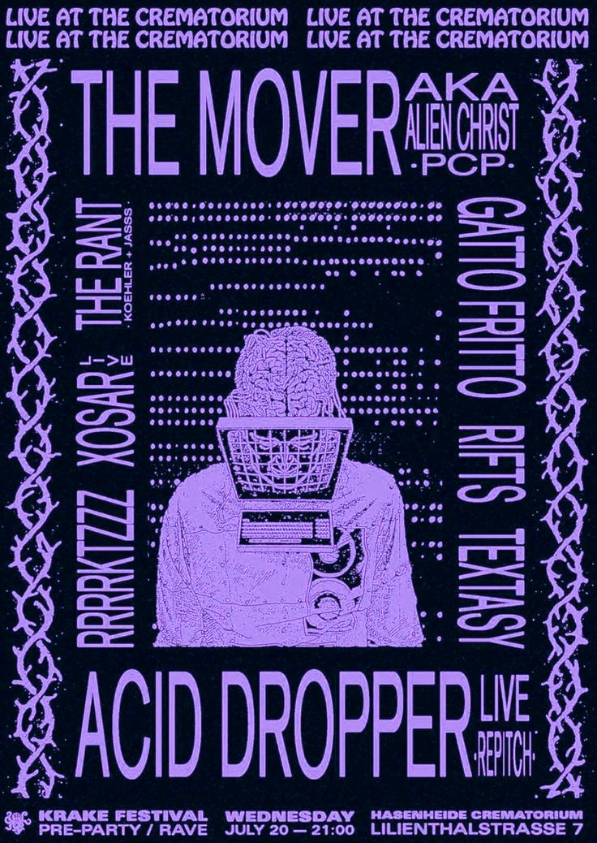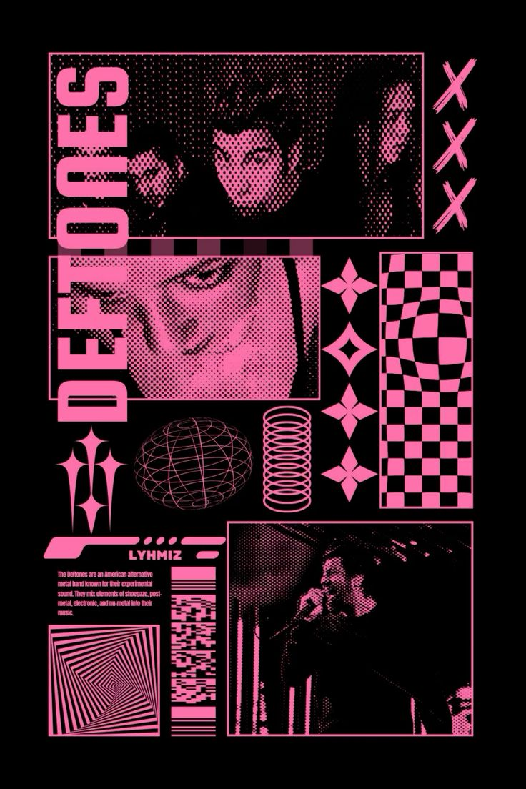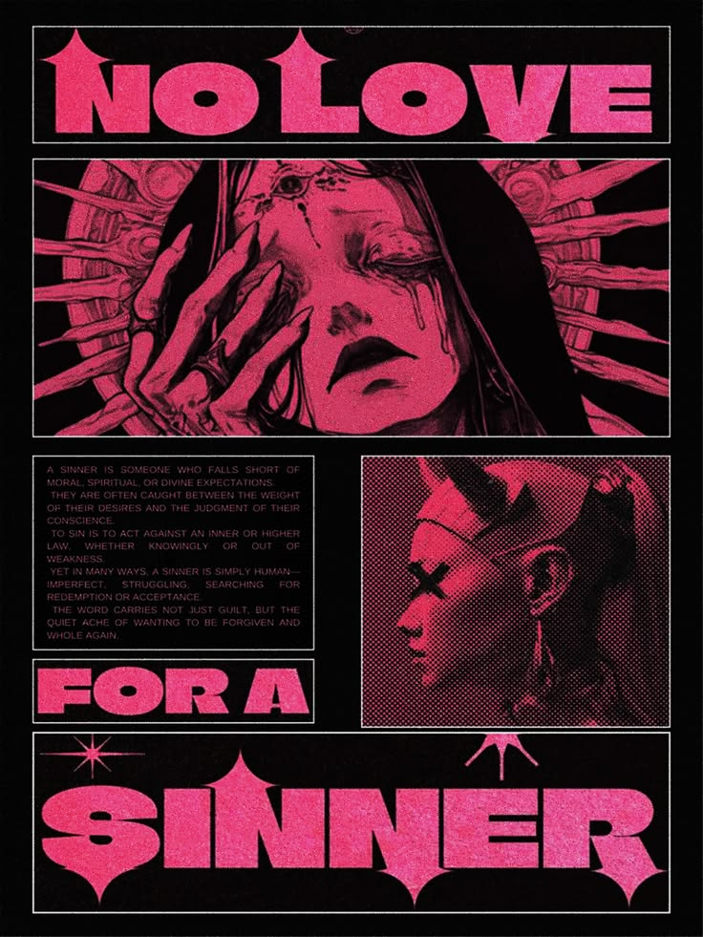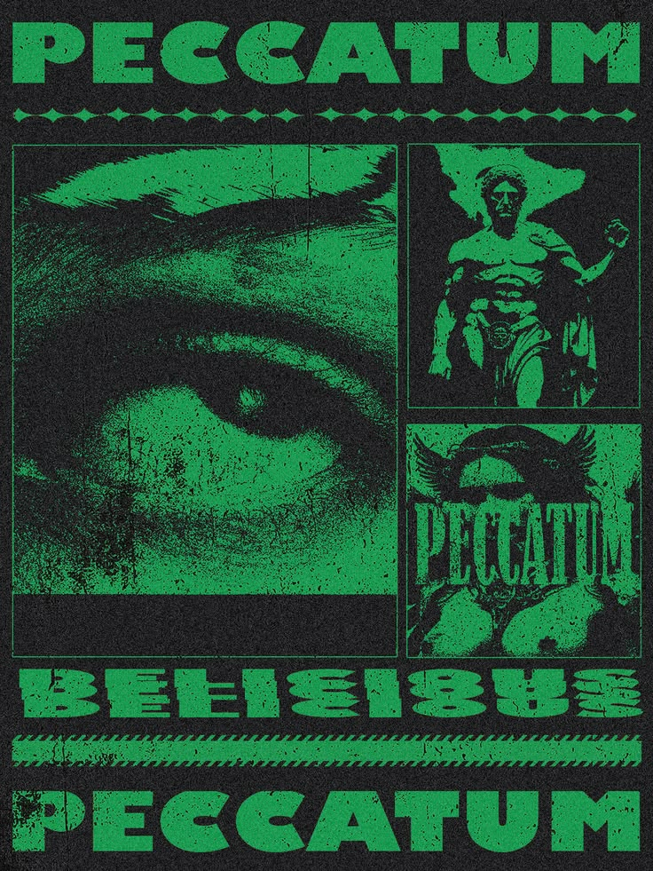

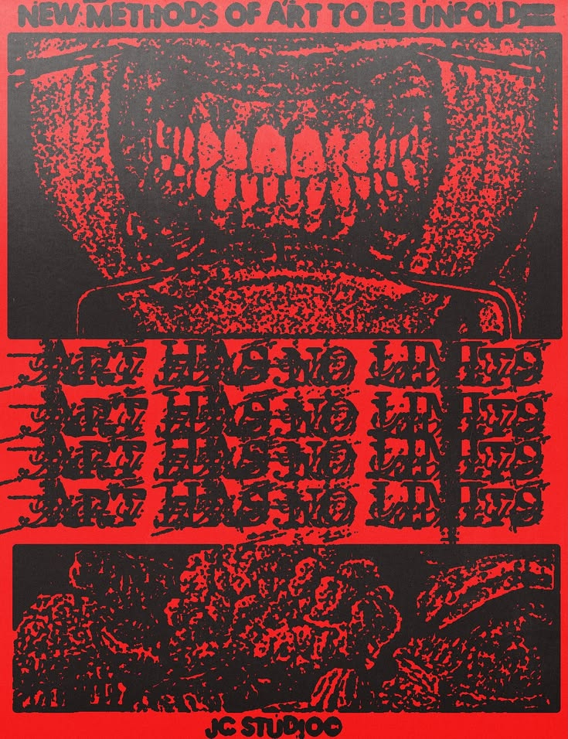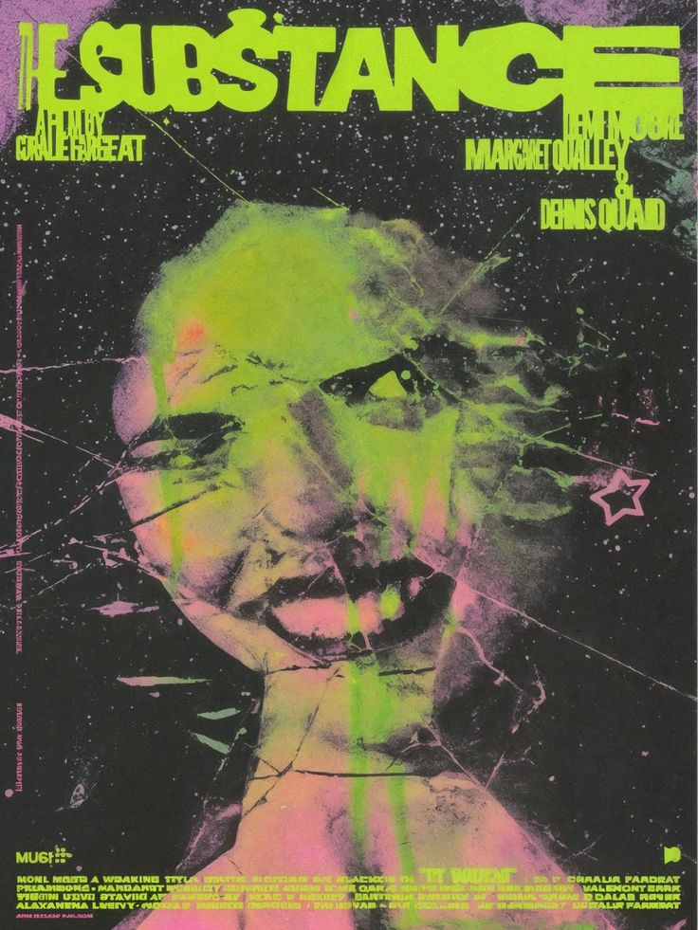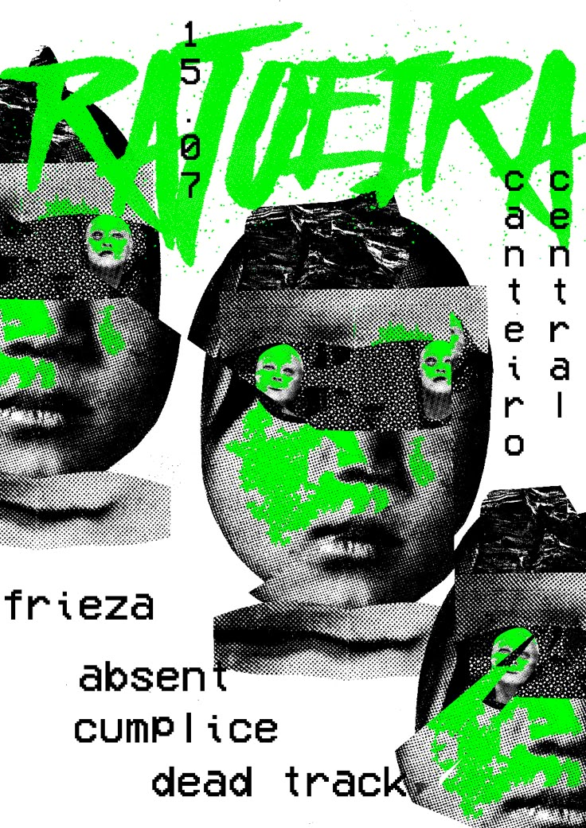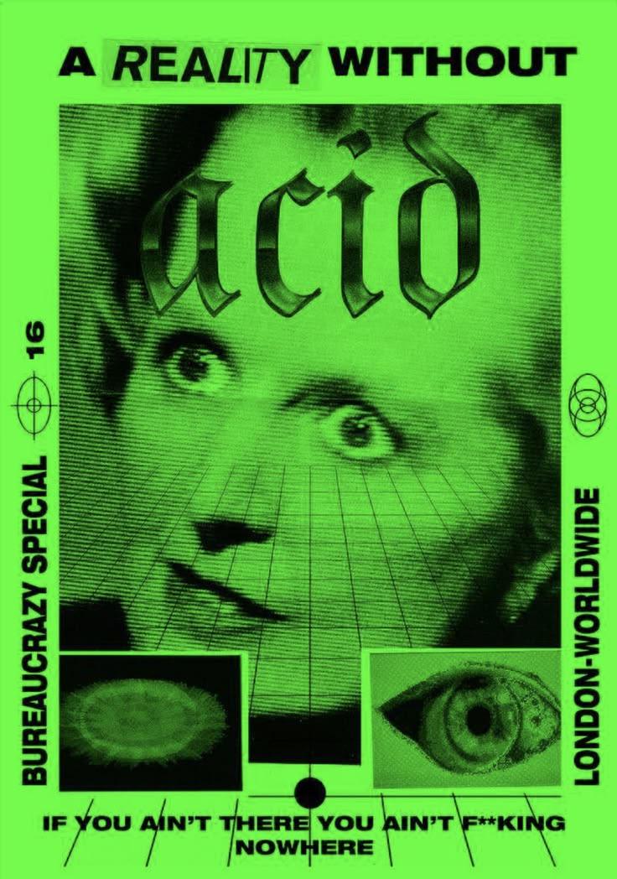

Punk

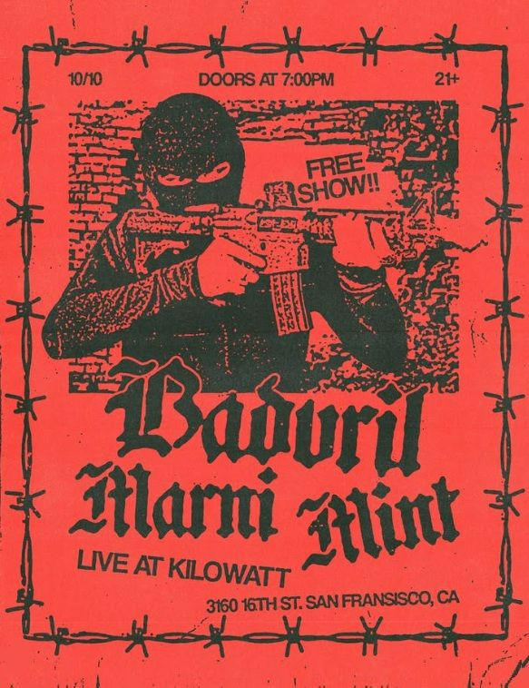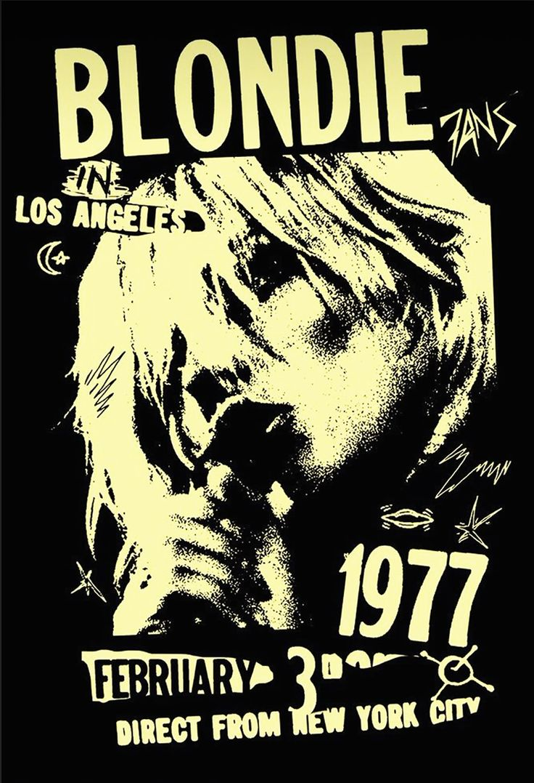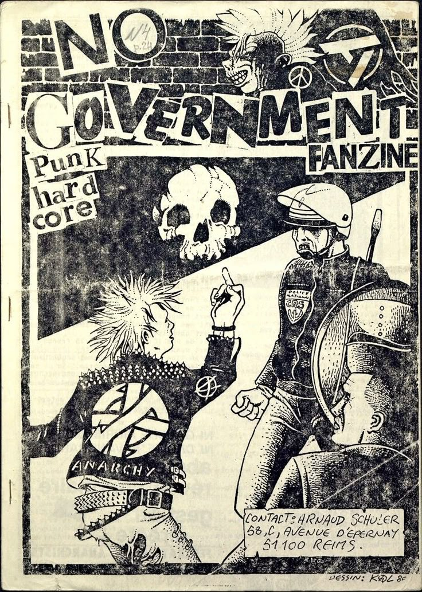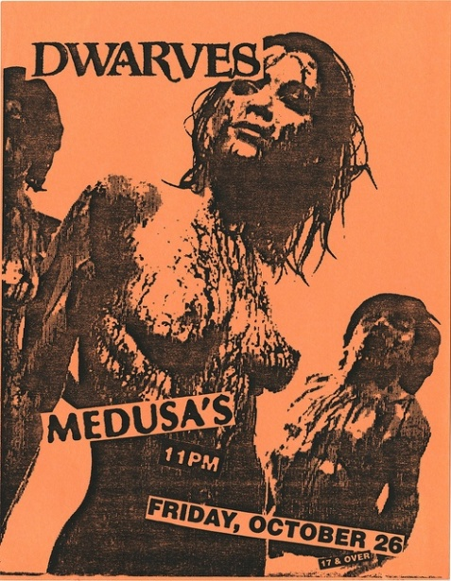

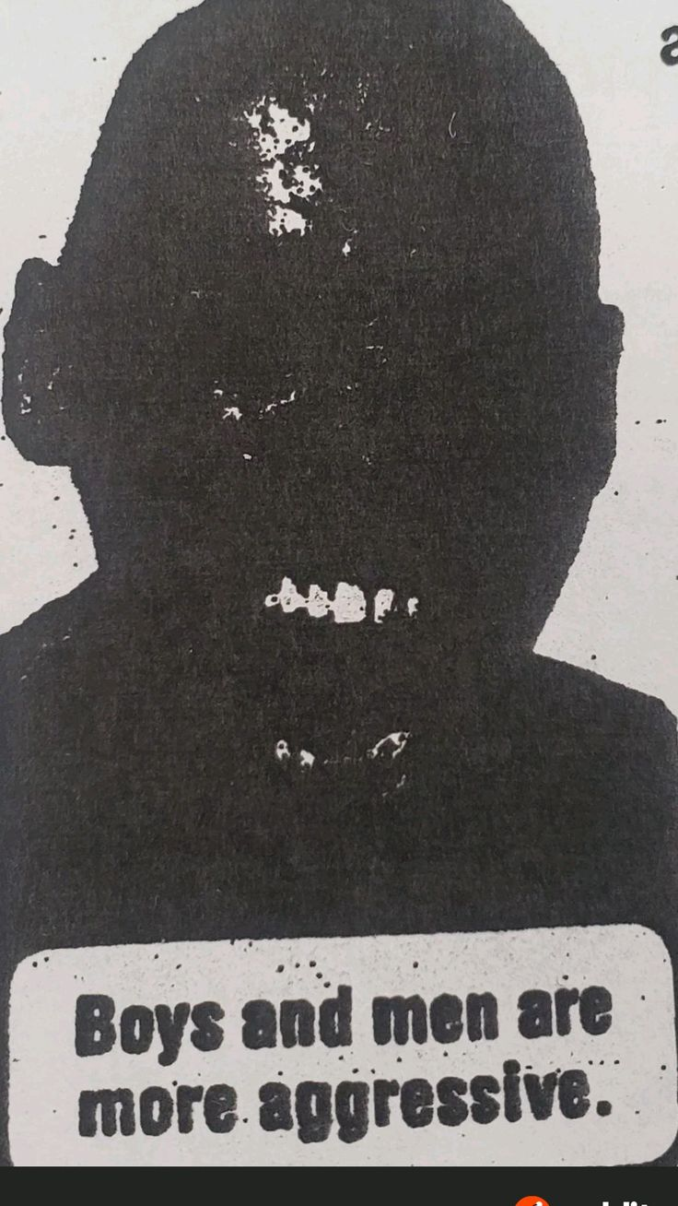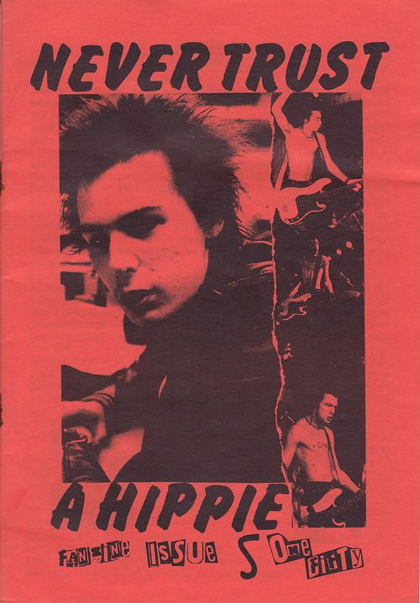
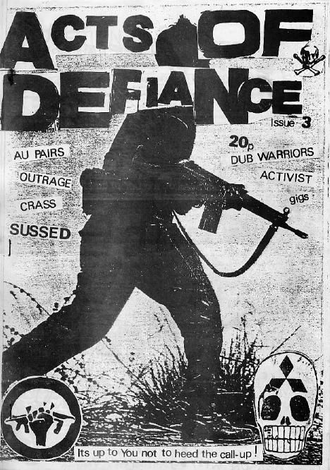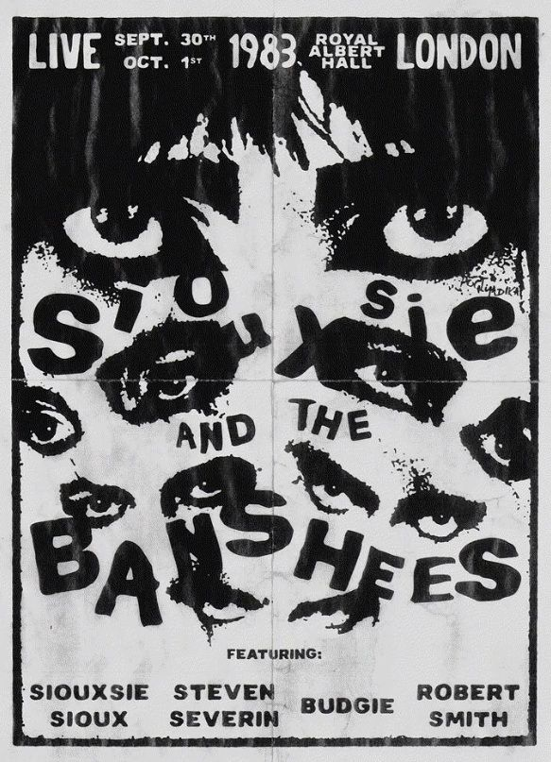

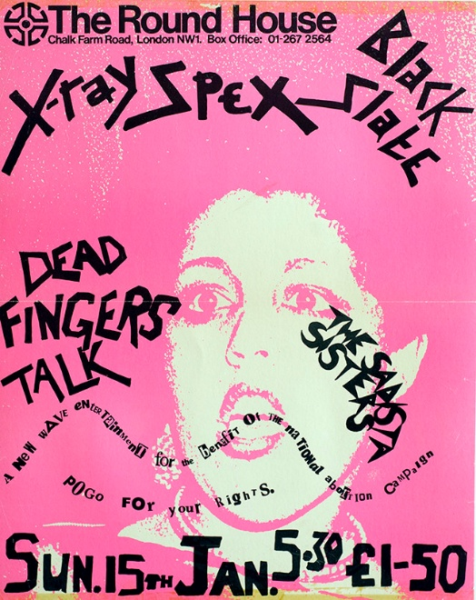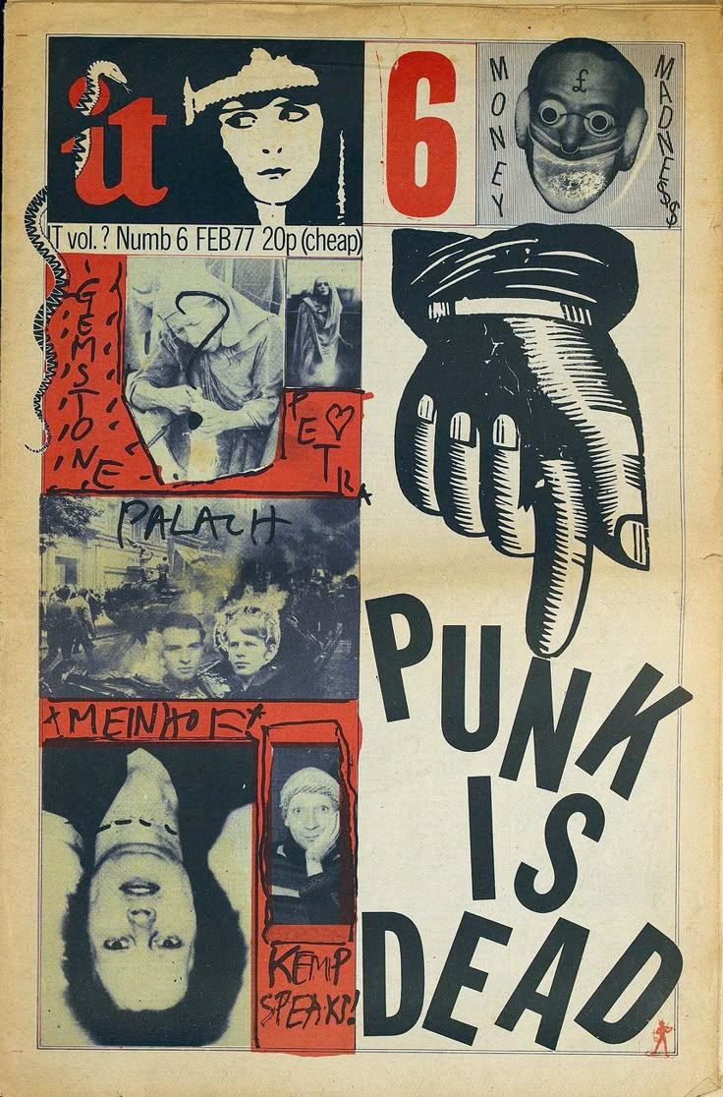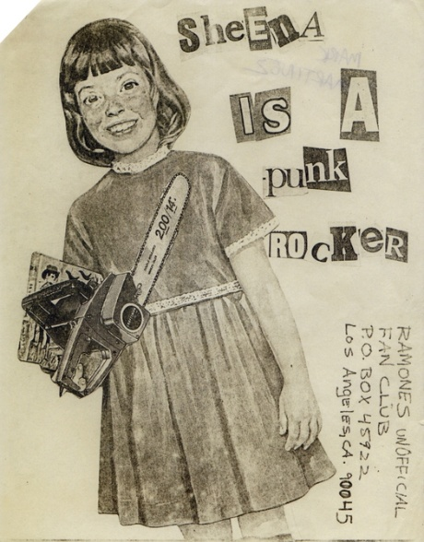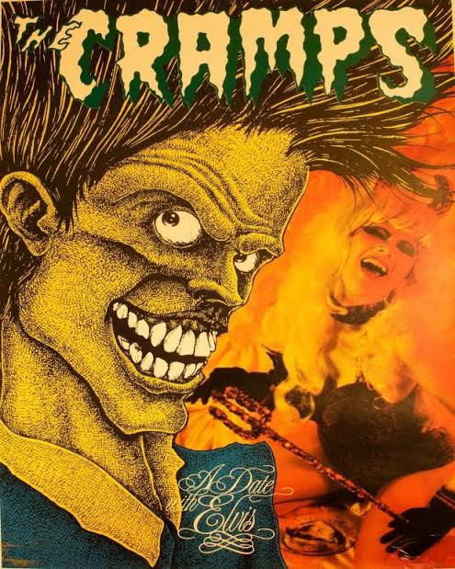

Punk Christianity

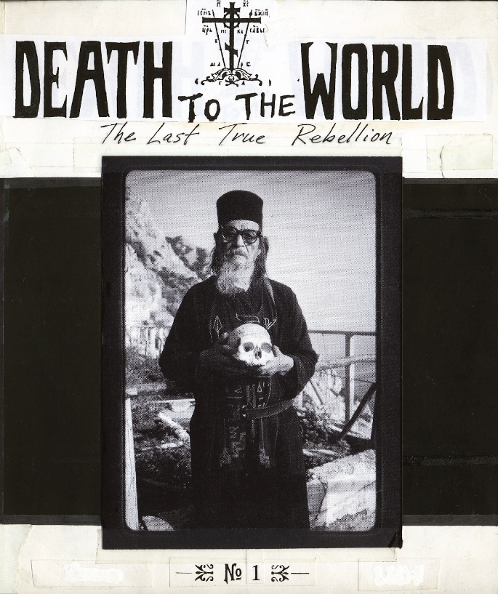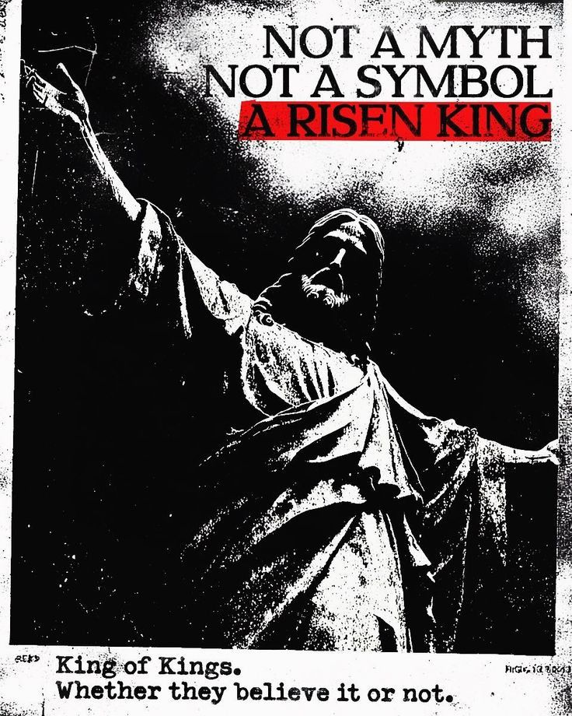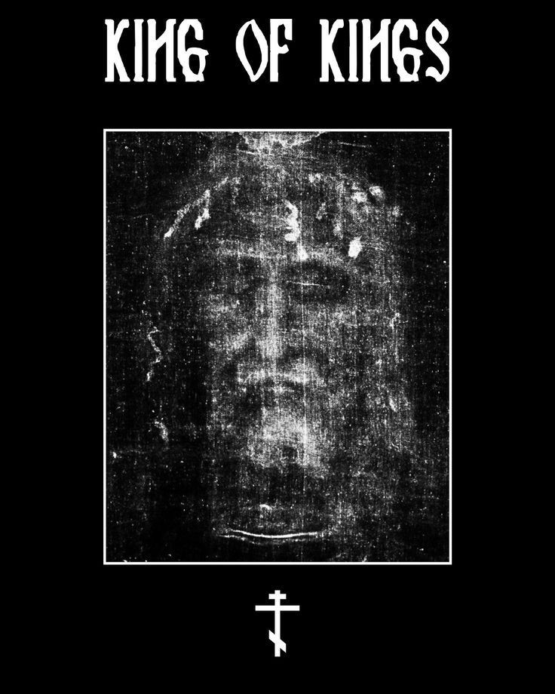

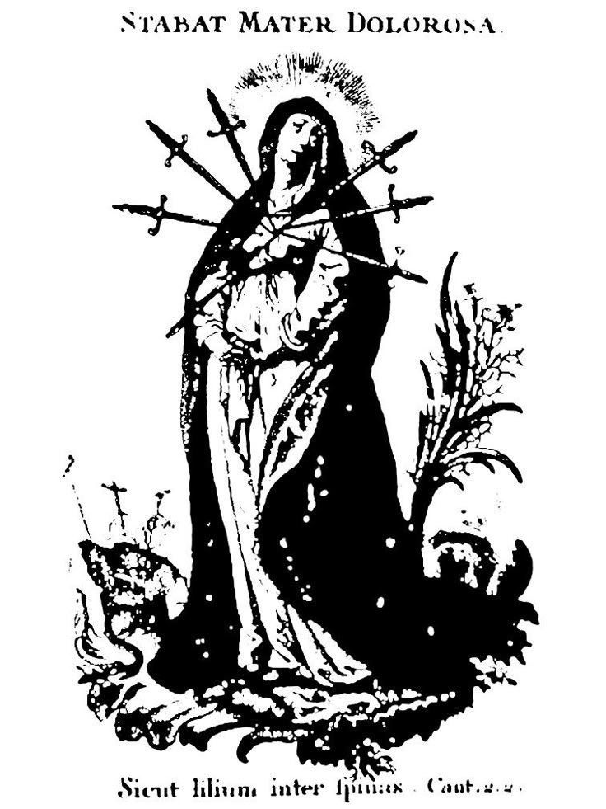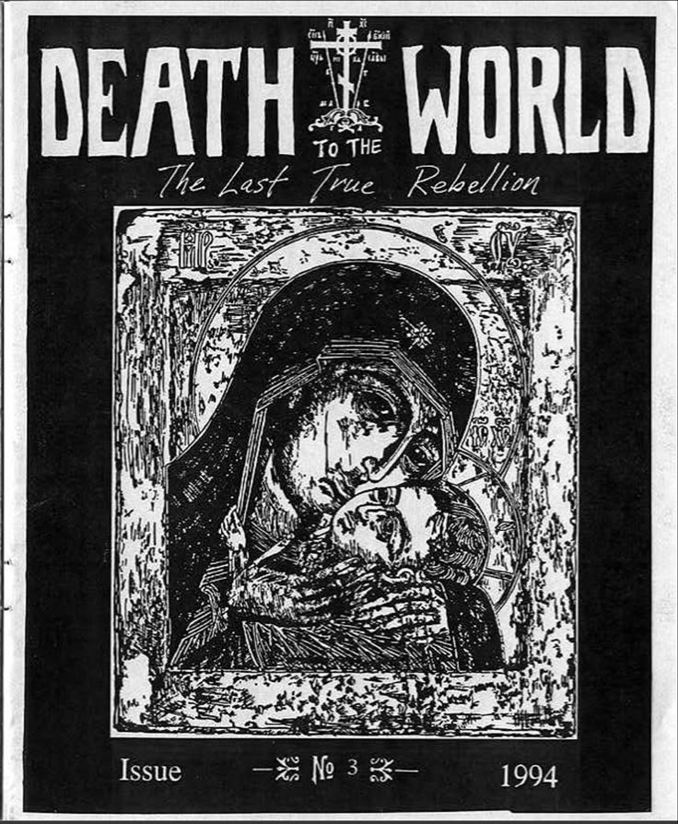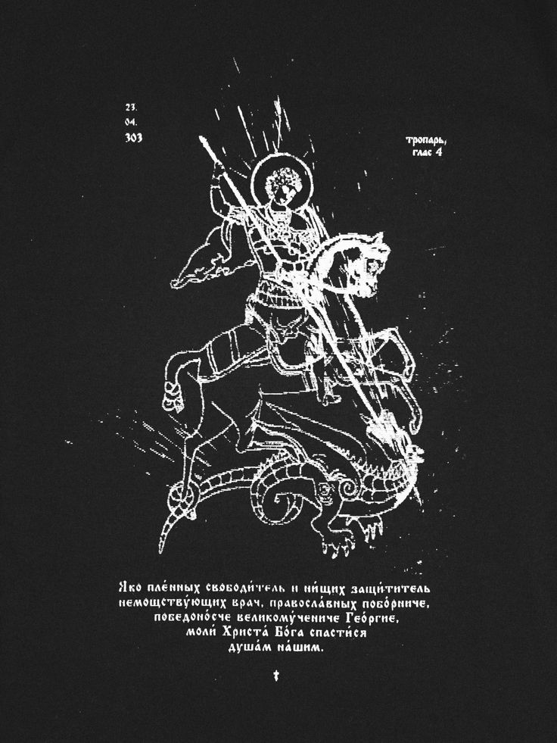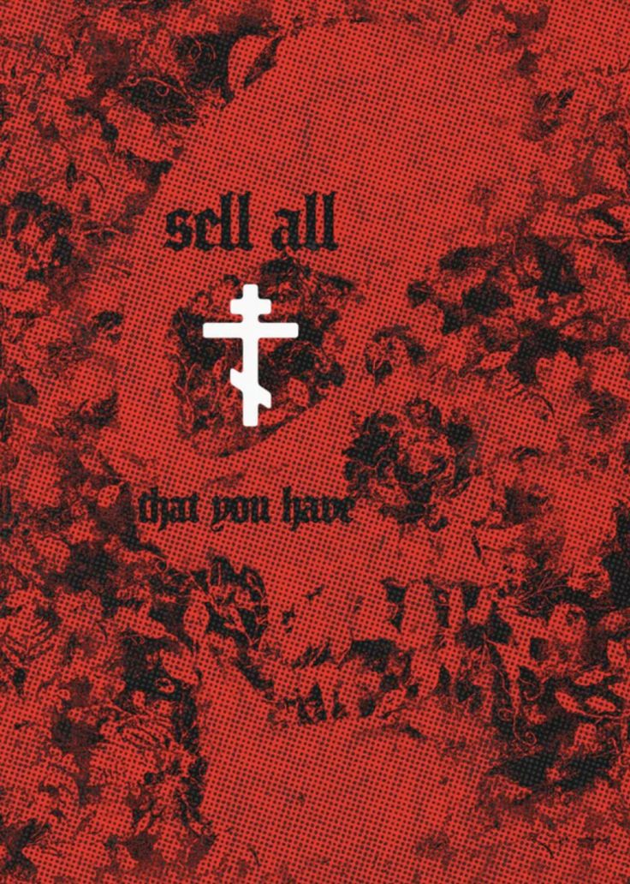

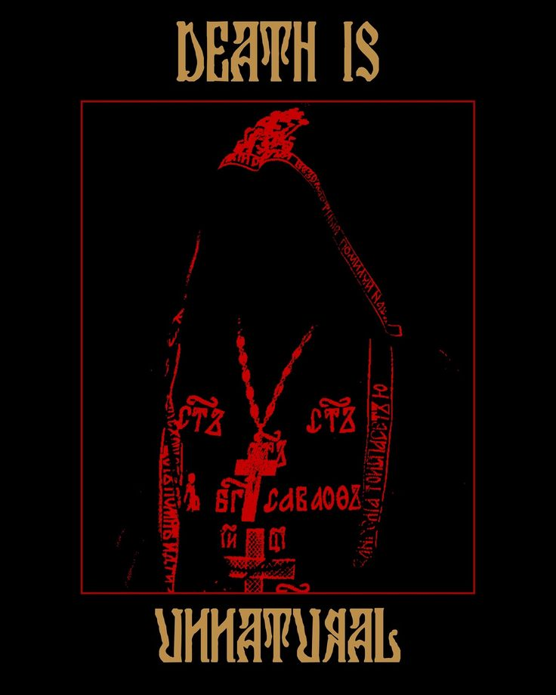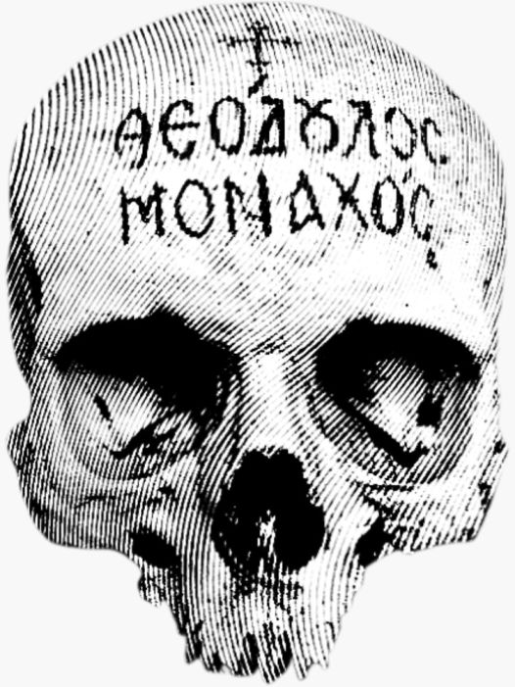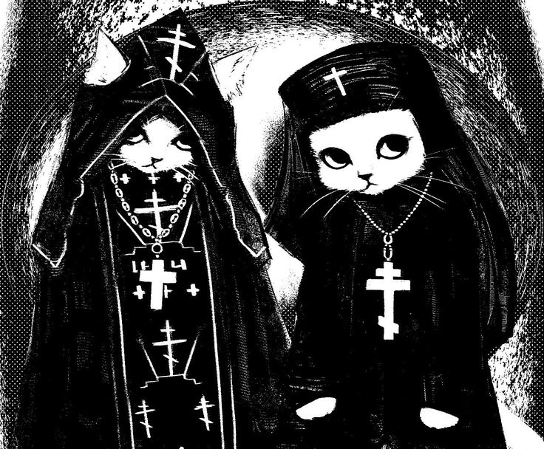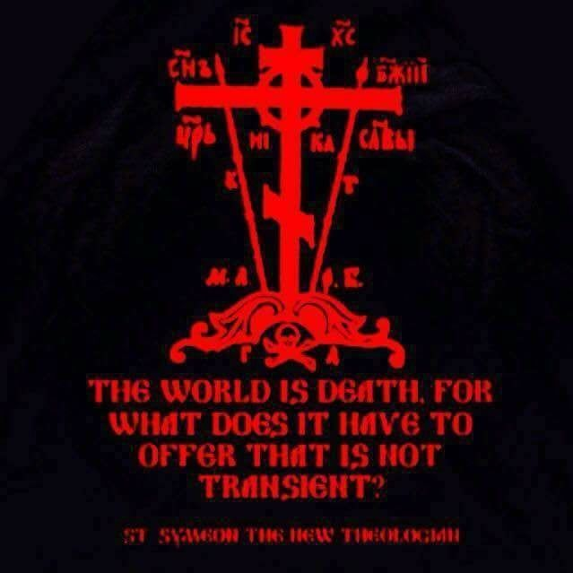

Death to the world
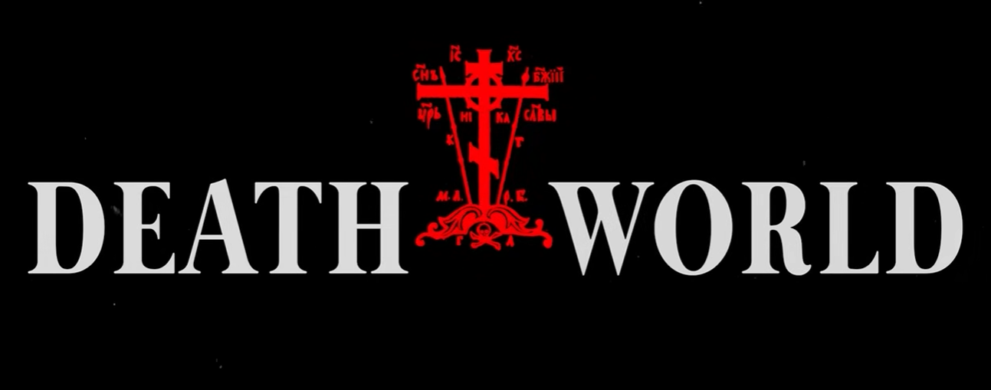
A lot of this aesthetic is heavily influenced by the 90s Orthodox magazine “Death to the world”.
In this Drive you can find some issues for visual reference.

If you want some video examples of this aesthetic, check the following:

- https://youtu.be/yC9VKhygjsA

- https://youtu.be/Sc27-dmJ_4wxc (30 mins, you don’t need to watch it all, just the first 4 mins are enough to catch the feeling)
The enemy
Though they appear monstrous, these enemies are ordinary men and women consumed by unchecked passions. Their masks are not disguises but symbols of the identities they choose to embody.
The aesthetic is gritty and realistic, drawing from underground subcultures and extreme groups active in the late 20th century. Their style echoes the disturbing “snuff bdsm” atmosphere, with inspiration from controversial films like 8MM and A Serbian Film, as well as Rockstar’s Manhunt.
While most enemies are human, a few supernatural figures exist—belonging to a separate, otherworldly realm.
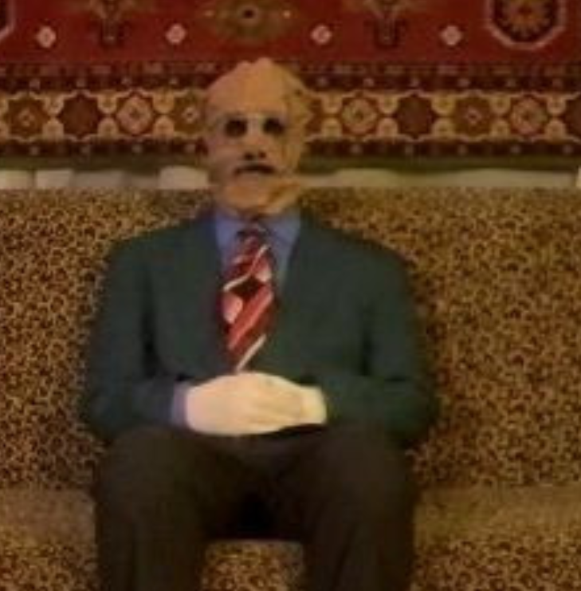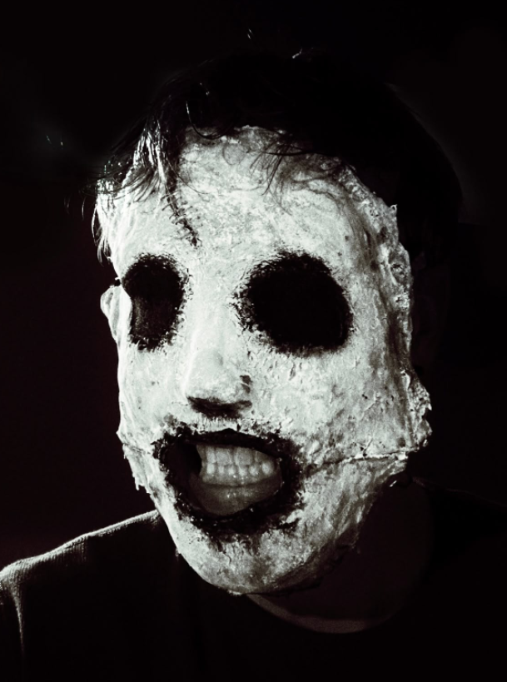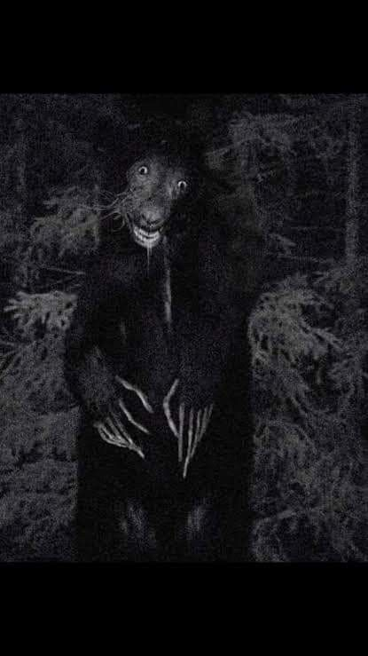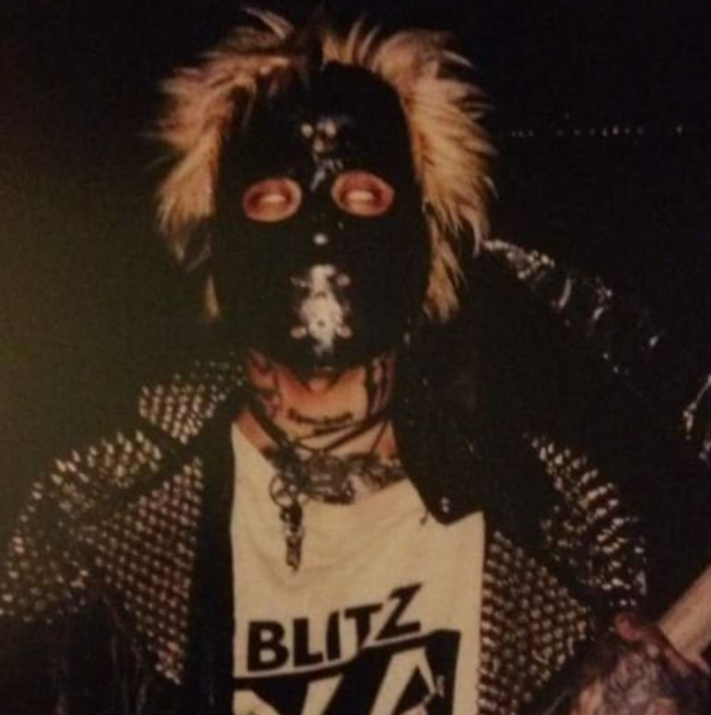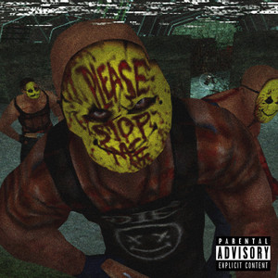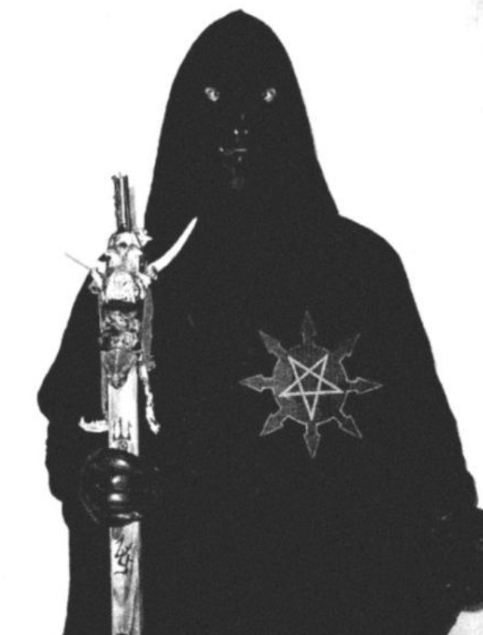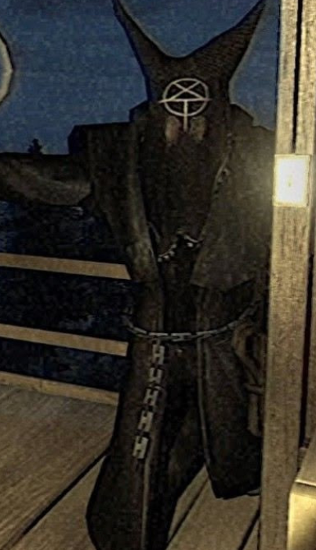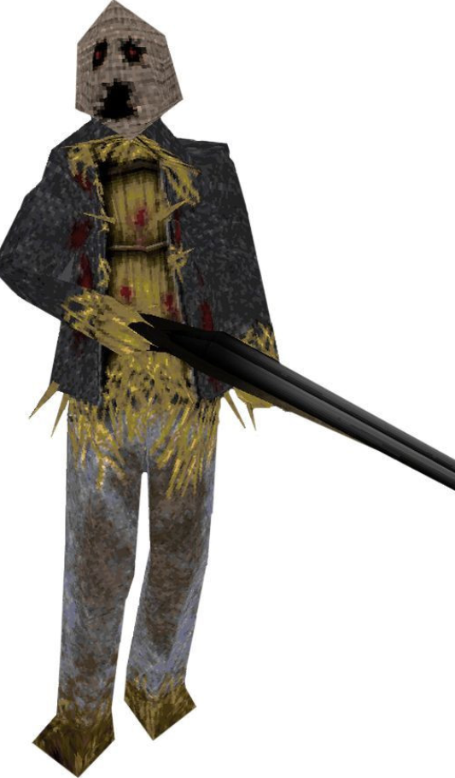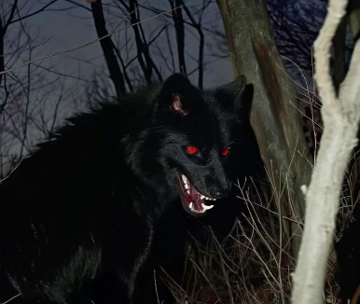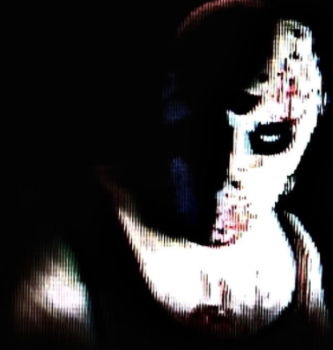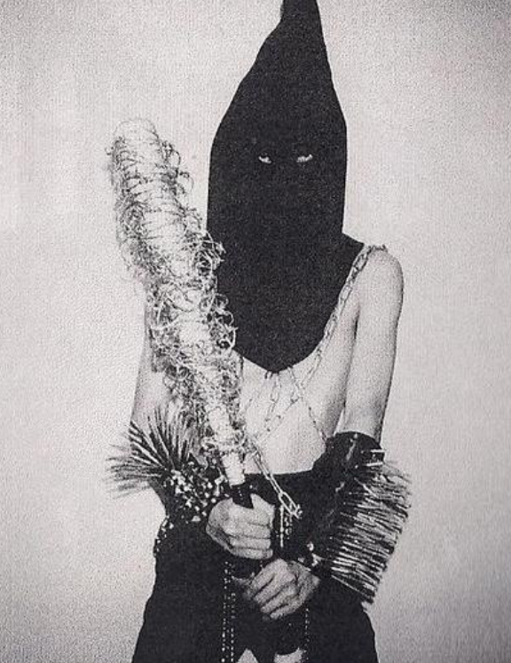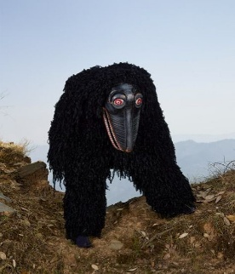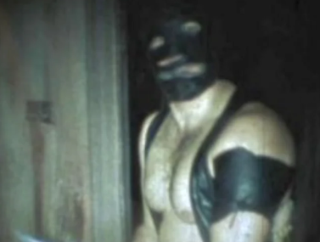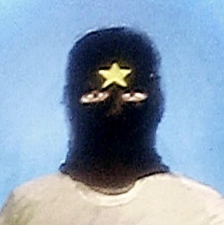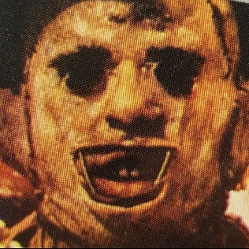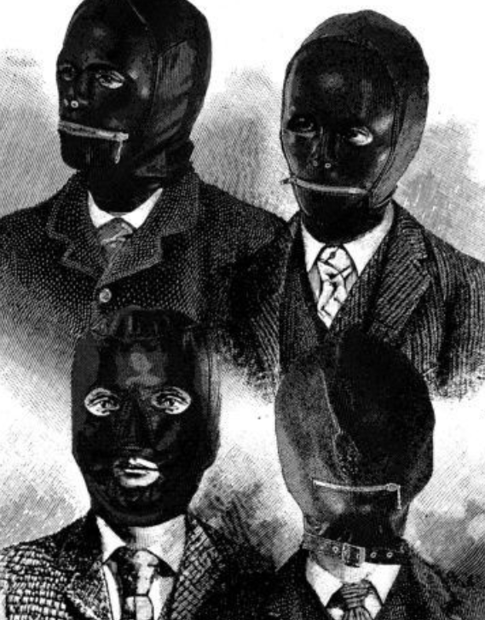
Character 3D style
The following are examples of what we want for the characters of this game (and what we try to avoid). It is low poly, highly stylized, and simple enough yet defined and human enough to be animated. The facial expressions won't be done with a rig, but with 2D textures.

YES (this is what we want) |  | NO (nah, this is boring)
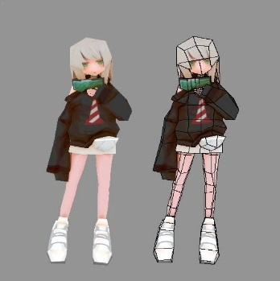 | Low poly higly stylized 3d models | 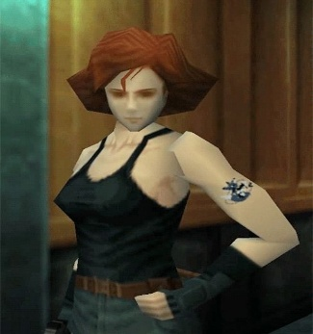 | low poly models that try to be realistic
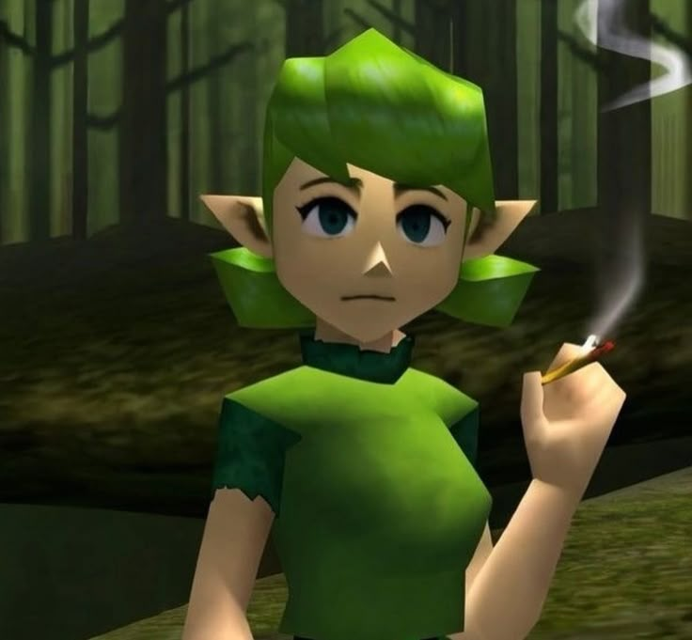 | Stylized facial expresions, texture swap, not rigged (watch the first 20 seconds of this video to understand better) | 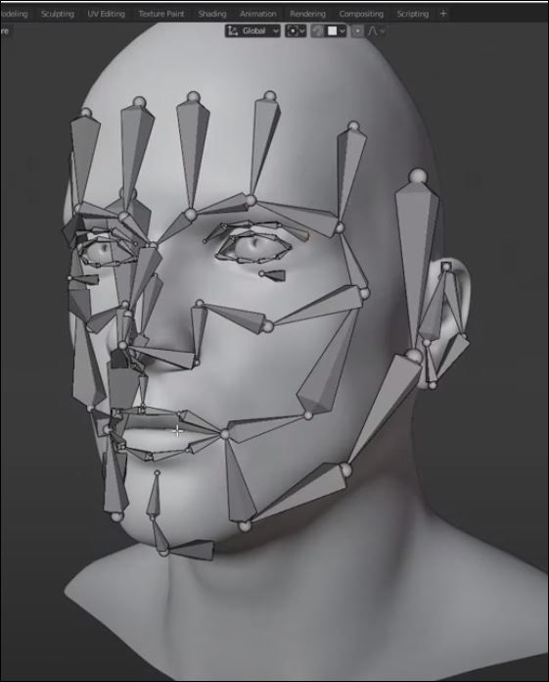 | Full face rig or blend shapes
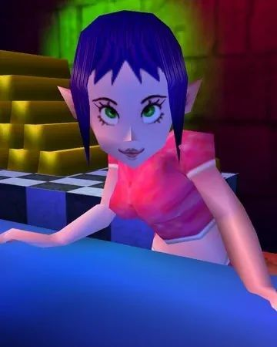 | Clever use of body language to convey emotions and personality | 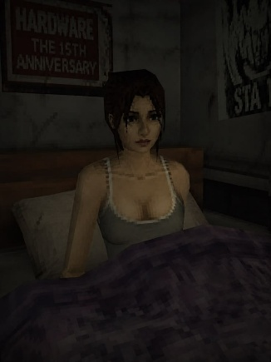 | Rigid postures, no natural spine
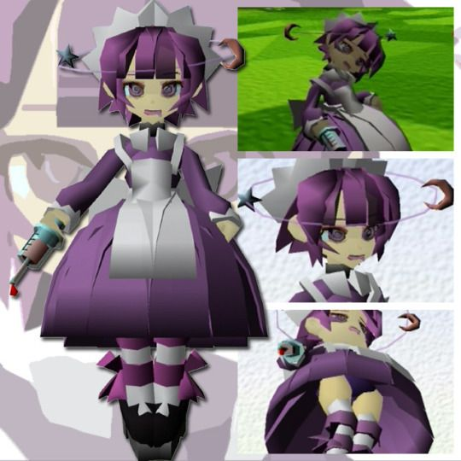 | Really expresive facial expresions that go with the character personality | 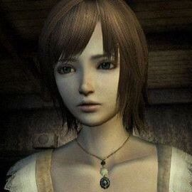 | Dull, boring “kdrama” limited facial expresions.
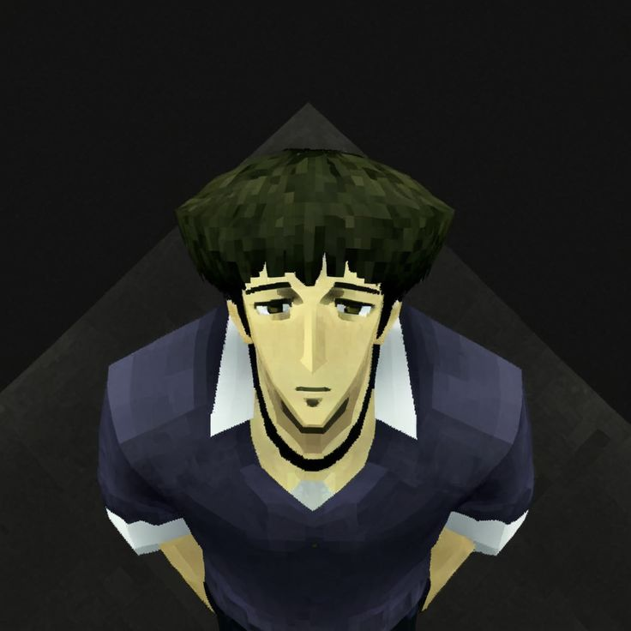 | Pixelated textures, akin with the rest of the game |  | Use of plain photos for the textures
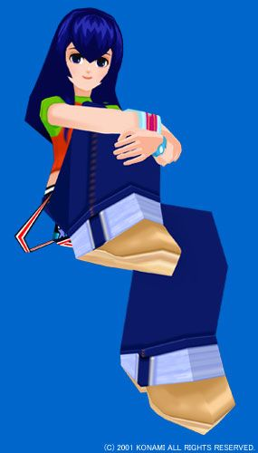 | Big blocky shapes, like the boots, each character has a distinctive shape and siluette | 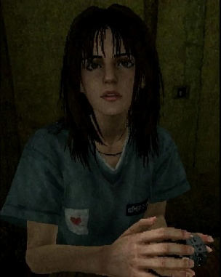 | conventional human figure and proportions, this is not a realistic game
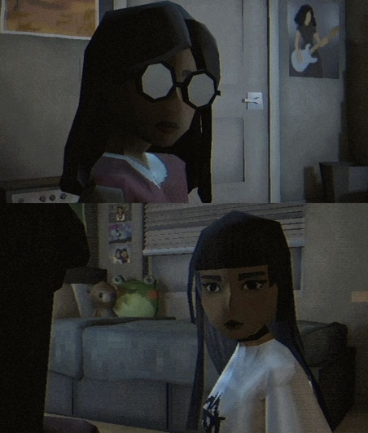 | we highlight specific details of the character | 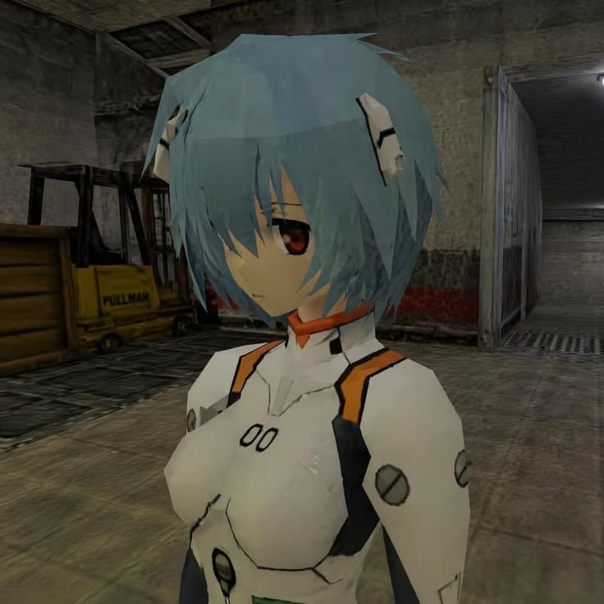 | Generic anime body (miku miku dance)

Audio
For the main menu and UI sections, a low psychedelic theme like the next video will be played. It will be a version of Requiem by Mozart, but in the 60s-70s rock psychedelic style.
https://youtu.be/Ksbf0A4iuoE
-------------------------------------------------------------
During heavy combat or persecution segments, heavy metal with sound effects of yelling and machinery will be displayed. A good example is the next one from War at War.
https://youtu.be/GNO0kArln1E
-------------------------------------------------------------
In very few important cutscenes, instrumental music like Dies Irae Requiem by Mozart will be played.
https://youtu.be/FGqoU9NIjZw
-------------------------------------------------------------
When outside of combat, especially when moving across the forest, it will be mainly just ambient music. There will be many props that will generate their own sound effect, like trees or certain spots that will play natural effects. Sometimes tricks and distant yelling will be used to create tension.
https://youtu.be/30zC6VR5CdI
-------------------------------------------------------------
Without sugarcoating it, I want brutal and realistic sound effects for the human sounds, especially yelling and pain sounds. Here is a good example of how realistic I want the sounds to be. I want to make the players feel uncomfortable. Some enemies, when you take them down, they won't be dead, they will be on the floor, yelling and moaning in pain.
https://youtu.be/poz3SE0pzdc
https://youtu.be/NDaRiyx9fYQ

